DemoQA Software Testing Project
Prepared By: Manoj Puthran
Course: MCA (3rd Semester)
Location: Mumbai Date: 20 November 2025

DemoQA — Software Testing Project
Purpose: A complete, interview-ready testing project for DemoQA (https://demoqa.com). This document contains test plan, scenarios, detailed test cases, test data, defect reporting templates, and a sample test execution summary.

1. Project Overview
Application Under Test (AUT): DemoQA — a publicly available demo site for UI components used for practice and learning.
Scope:
- Functional testing of the Elements and Forms modules (Text Box, Check Box, Radio Button, Web Tables, Buttons, Links, Upload/Download, Dynamic Properties, Practice Form).
- UI and basic accessibility checks.
- Basic negative testing and boundary conditions.
Out of Scope:
- Back-end load/performance testing beyond simple responsiveness checks.
- Security testing requiring privileged access or scraping.
Tested on Browsers: Chrome (latest), Edge (latest), Firefox (latest)
Tested on Devices: Desktop (Windows 10/11), Mobile viewport responsive checks (Chrome DevTools mobile emulation)

2. Objective
To validate core functionalities, input validation, UI behavior, and major user flows on DemoQA’s Elements and Forms sections and to produce a professional test report demonstrating testing skills to interviewers.

3. Test Plan (High level)
Testing Types: Functional, UI, Usability, Regression (smoke), Cross-browser compatibility, Positive/Negative.
Entry Criteria:
- DemoQA site reachable (https://demoqa.com)
- Test environment (browser) installed
- Test cases prepared
Exit Criteria:
- All high-severity defects fixed or accepted with risk
- All planned test cases executed
Risks & Mitigation:
- Demo site changes frequently — snapshot important features and include dates in reports. Mitigation: note page version/date and capture screenshots.

4. Test Scenarios (by feature)
- Text Box — Verify required fields, input validation (email), long inputs, and form submission results.
- Check Box — Verify selecting parent/child nodes, expand/collapse behavior, and selection persistence.
- Radio Button — Verify selection states and disabled state behavior.
- Web Tables — Add/Edit/Delete rows, search/filter functionality, pagination (if present), validation of inputs.
- Buttons — Click, double-click, right-click actions produce expected responses.
- Links — Verify navigation, new tab opens, and broken link detection (404 vs expected behavior).
- Upload & Download — Upload file validation and successful download.
- Dynamic Properties — Elements enabling/disabling after delay, color changes, visibility changes.
- Practice Form — Complete form inputs, validations (email, phone), date picker, dropdowns, file upload.

5. Test Case Template (fields used)
- TC ID
- Module/Feature
- Test Scenario
- Pre-conditions
- Test Steps
- Test Data
- Expected Result
- Actual Result
- Status (Pass/Fail/Blocked)
- Remarks
- Defect ID (if any)

6. Sample Detailed Test Cases

TC-EL-001 — Text Box — Valid Submission
- Module: Elements → Text Box
- Pre-conditions: DemoQA is accessible and browser is open.
- Test Steps:
  - Navigate to https://demoqa.com/text-box
  - Enter Full Name = Manoj Puthran
  - Enter Email = manoj@example.com
  - Enter Current Address = 123 Demo Street, Mumbai
  - Enter Permanent Address = 456 Example Lane, Mumbai
  - Click Submit
- Test Data: See steps above.
- Expected Result: Submitted data should appear in the output box with correct values and email should be recognized as valid.
- Actual Result: [To be filled during execution]
- Status: [Pass/Fail]

TC-EL-002 — Text Box — Invalid Email Validation
- Module: Elements → Text Box
- Pre-conditions: Page loaded
- Test Steps:
  - Go to Text Box page
  - Enter an invalid email: manoj@com
  - Click Submit
- Expected Result: Site should either show client-side validation or accept but display the invalid email in output. Note the observed behavior.

TC-EL-003 — Check Box — Select Parent Node
- Module: Elements → Check Box
- Pre-conditions: Page loaded
- Test Steps:
  - Navigate to Check Box page
  - Click the Home checkbox (parent)
- Expected Result: All child nodes become checked and UI shows selection text (e.g., “You have selected :” with items).

TC-EL-004 — Radio Button — Validate Disabled Option
- Module: Elements → Radio Button
- Pre-conditions: Page loaded
- Test Steps:
  - Navigate to Radio Button page
  - Try clicking the disabled radio option (if present)
- Expected Result: Disabled option should not be selectable; cursor may indicate disabled.

TC-EL-005 — Web Tables — Add New Record
- Module: Elements → Web Tables
- Pre-conditions: Page loaded
- Test Steps:
  - Navigate to Web Tables
  - Click Add button
  - Fill form: First Name Test, Last Name User, Email test.user@example.com, Age 25, Salary 30000, Department IT
  - Click Submit
- Expected Result: New row with entered details is added to the table and searchable.

TC-EL-006 — Buttons — Double Click Action
- Module: Elements → Buttons
- Test Steps:
  - Go to Buttons page
  - Double-click the Double Click Me button
- Expected Result: Page displays a message confirming a successful double-click.

TC-EL-007 — Links — Verify New Tab Link
- Module: Elements → Links
- Test Steps:
  - Click Home link that opens in a new tab
- Expected Result: A new tab opens and navigates to the DemoQA home page (status 200). Verify URL and page title.

TC-FRM-001 — Practice Form — Full Valid Submission
- Module: Forms → Practice Form
- Pre-conditions: Page loaded
- Test Steps:
  - Fill First Name Test and Last Name User
  - Email test.user@example.com
  - Select Gender Male (or preferred)
  - Mobile 9876543210
  - Date of Birth 10 Oct 1998
  - Subjects Maths
  - Hobbies Sports
  - Upload Picture: sample.jpg
  - Current Address Test Address
  - Select State and City
  - Click Submit
- Expected Result: Modal dialog opens with submitted data summary. All inputs match.

7. Test Data Sheet (sample)
Test Data ID | Field | Value
TD1 | Valid Email | valid.user@example.com
TD2 | Invalid Email | invalid@com
TD3 | Phone number (valid) | 9876543210
TD4 | Long text | 1000-character lorem ipsum string

8. Defect Reporting Template
- Defect ID: DEF-001
- Summary: Short summary of bug
- Module: (Text Box / Web Tables / etc.)
- Severity: Critical / Major / Minor / Trivial
- Priority: P0 / P1 / P2
- Environment: Browser + OS + Date
- Steps to Reproduce: (Numbered steps)
- Test Data: (if any)
- Actual Result:
- Expected Result:
- Attachments: Screenshot(s) — include image filenames and timestamp
- Status: New / Assigned / Fixed / Closed

Example Defect (sample filled)
- Defect ID: DEF-101
- Summary: Text Box form accepts invalid email format manoj@com without validation.
- Module: Elements → Text Box
- Severity: Major
- Priority: P1
- Environment: Chrome 118 on Windows 10 — 2025-11-26
- Steps to Reproduce:
  - Open Text Box page
  - Enter manoj@com in Email
  - Click Submit
- Actual Result: Form submission accepted and output shows manoj@com.
- Expected Result: Client-side validation should flag the email as invalid or show an error message.
- Attachments: DEF-101_textbox_invalid_email_20251126.png
- Status: New

9. Sample Test Execution Summary (template)
- Date: 2025-11-26
- Tested By: [Your Name]
- Total Test Cases: 25 (example)
- Executed: 25
- Passed: 18
- Failed: 5
- Blocked: 2
- Defects Logged: 6 (2 Critical, 3 Major, 1 Minor)
Observations & Recommendations:
- Several input validation issues observed — recommend adding client-side validation for email and phone fields.
- Buttons and dynamic properties mostly stable; ensure timing-based tests have retries.

10.Screenshots
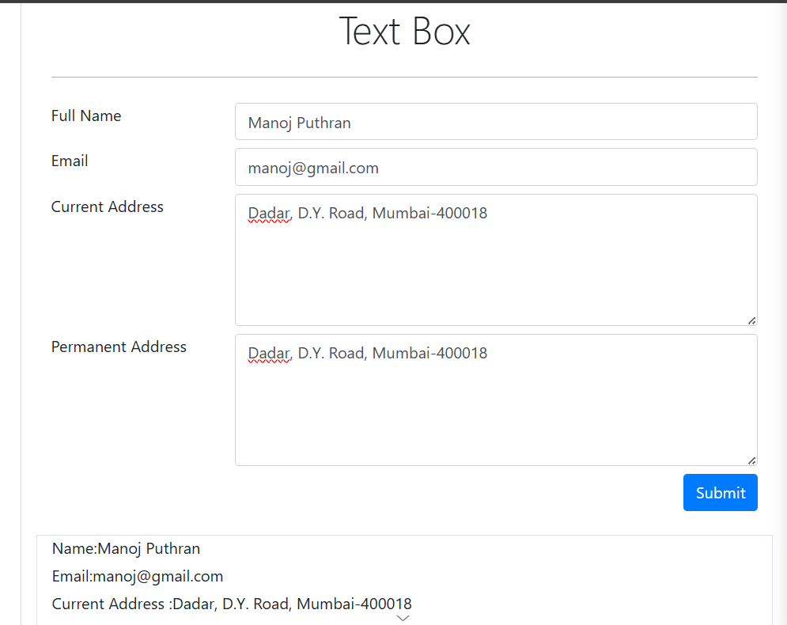
2.Broken Links
